CSIS1175 Week 5 exercise

This exercise combines what we had learned a few weeks ago about the avg of the best 3 out of 4 and simple file input.

Given the data file called week5data1.txt stored and accessed in c:\temp

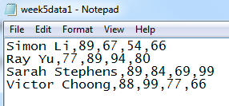

Write a simply program that will read in the data and show the content together with the average best 3 out of 4 quizzes for each of the students. You have to assume that you do not know much about the contents of the data file. The data format (such as each field is separated by a comma) is known though.

